Indonesia Encourages Strengthening ASEAN-India Cooperation in Food Security

Jakarta, 13 July 2023 – Indonesia is pushing for strengthened cooperation in the field of food security between ASEAN and India. This was conveyed by the Foreign Minister of the Republic of Indonesia, Retno Marsudi, during the meeting of ASEAN Foreign Ministers with the Indian Foreign Minister in Jakarta (13/7).

"The growing population of ASEAN and India depends on food security. Therefore, we need to make more efforts to ensure the availability, accessibility, and affordability of food during crises," said Minister Retno.

Such cooperation needs to focus on building a sustainable food supply chain through trade, dialogue, and transparent government policies," added Retno.

Indonesia also encourages long-term collaboration in agricultural technology and research centers to enhance local food production and benefit small-scale farmers.

Indonesia will propose a Joint Statement of ASEAN Leaders on Strengthening Cooperation in Food Security during Crises to be adopted at the upcoming ASEAN-India Summit.

The second issue raised by Minister Retno is peace and prosperity in the Indo-Pacific region. Indonesia appreciates India's support for the ASEAN Outlook on the Indo-Pacific (AOIP) and invites India to participate in the ASEAN Indo-Pacific Forum as a platform for government-private sector dialogue for concrete cooperation.

"We all have a responsibility to maintain peace and security in the Indo-Pacific. India and ASEAN can be part of these efforts. Every minilateral group should support these endeavors," said Minister Retno.

In this context, ASEAN will invite IORA (Indian Ocean Rim Association) and PIF (Pacific Islands Forum) to the East Asia Summit (EAS) to promote a more inclusive regional architecture in the Indian and Pacific Oceans.

Indian Foreign Minister Subrahmanyam Jaishankar expressed support for ASEAN's centrality, the implementation of the AOIP, and the plan to hold the ASEAN-Indo-Pacific Forum in Jakarta in September.

During the meeting, issues that were discussed included the importance of ASEAN's centrality in maintaining regional peace and stability, the development of an inclusive regional architecture, cooperation in food security, health, cybersecurity, climate change, digital economy, blue economy, and trade.

The relationship between ASEAN and India has become a Comprehensive Strategic Partnership since November 2022. The ASEAN-India Strategic Partnership Action Plan 2021-2025 has achieved around 86% of its targets. The meeting adopted the Annex to the Plan of Action to Implement the ASEAN-India Partnership for Peace, Progress, and Shared Prosperity (2021-2025).

***

For further information, please contact the following:

Director for Information and Media of the Ministry of Foreign Affairs - Hartyo Harkomoyo (+62811831899)

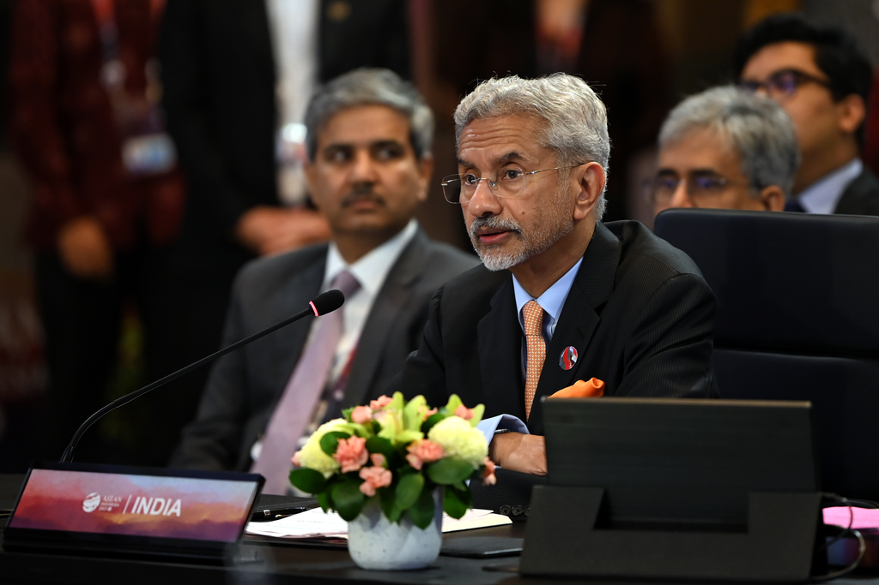

Indonesia is pushing for strengthened cooperation in the field of food security between ASEAN and India during the meeting of ASEAN Foreign Ministers with the Indian Foreign Minister in Jakarta (13/7) (Photo: Ministry of Foreign Affairs of Indonesia).

